First go in Server info and take your VDI hostname by cmd like mine-

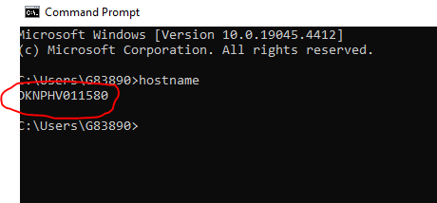

Then go to server info page and click on VDI machines--

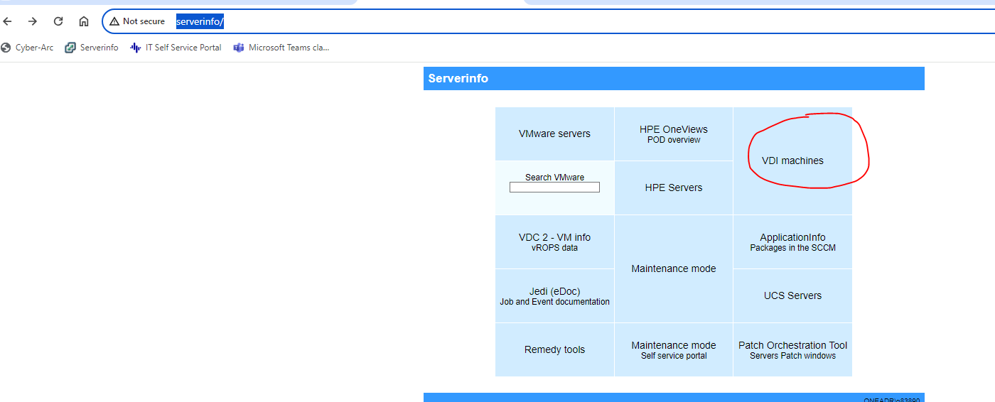

And search for your VDI hostname like below-

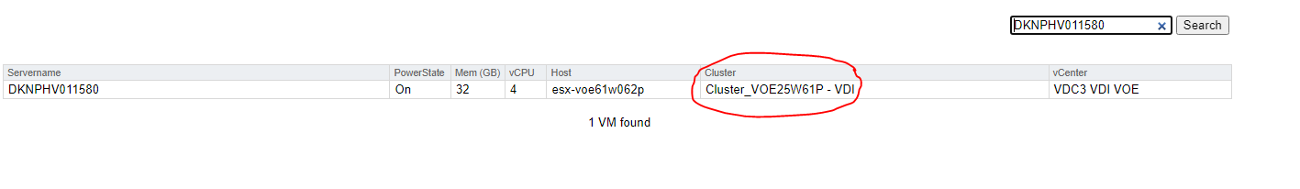

So here you can find your existing VDI is from VHH side or VOE Side, then order new VDI for other side by below process--

